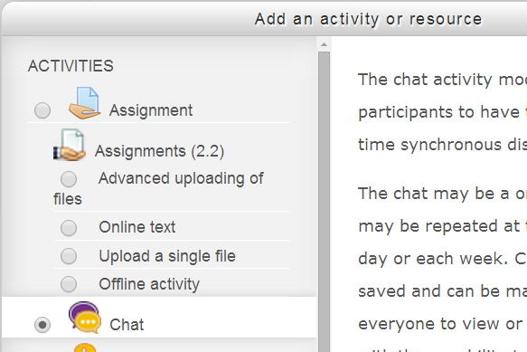
Activities: Chat
The Chat activity module enables participants to have text-based, real-time synchronous discussions. The Chat may be a one-time activity or it may be repeated at the same time each day or each week. Chat sessions are saved and can be made available for everyone to view or restricted so that users only have the ability to view chat session logs.
Chats are especially useful when students are not able to meet face-to-face. Some examples of how an Instructor may use Chats are:

- Regular meetings with online students to enable their sharing of experiences with others.
- A student temporarily unable to attend class in person or synchronously online; they can chat with their instructor to catch up with work.
- Students out on work terms getting together to discuss their experiences with each other and their instructor.
- Sessions to help students prepare for tests where the instructor, or other students, could pose sample questions.

Contents
- Add a Chat
- Edit Chat Settings
- Using a Chat
- Chat Reports
- Delete a Chat
- Notes

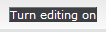
To Add a Chat Room:

- Turn editing on by clicking the ‘Turn editing on’ button on the top right of your screen.

- Click the ‘Add an activity or resource’ button on the bottom right of the section (location) where you want to add the new file.


- A pop-up window will appear on your screen. Scroll down. Under ‘Activities,’ select the ‘Chat’ option. Click ‘Add’ at the bottom of the window.

Edit Settings:
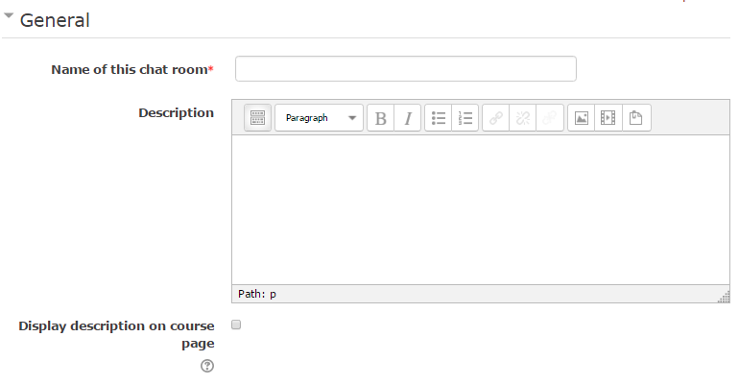
1
2

  - Fill in the Chat name. Ensure the name of the Chat identifies the purpose of the Chat activity. For example, ‘Chat for studying for Mid-term’ or ‘Chat for asking Instructor Questions.’

  - In the Description field you may give the student more details on the Chat activity. You may display the Description on the course page if you select the Display description on the course page box. Only do this if it is imperative to give the students further directions before they enter the Chat. Having descriptions on the course page ‘clutters’ the home page, making navigation through your course more difficult for the student.

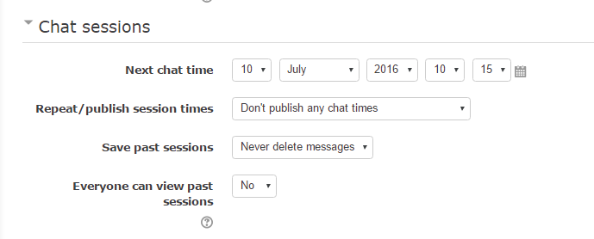
6
5
4
3
  - Next Chat time is when this virtual chat room will be open for use. It is important to have the correct day, year and time that you would like to use this feature.
  - Repeat/publish session times can be used for daily or weekly chats. The time you select does not enable/disable the chat room. It only tells students when to expect activity.
To disable a chat room, see Common module settings>Visible. Change form Show to Hide.
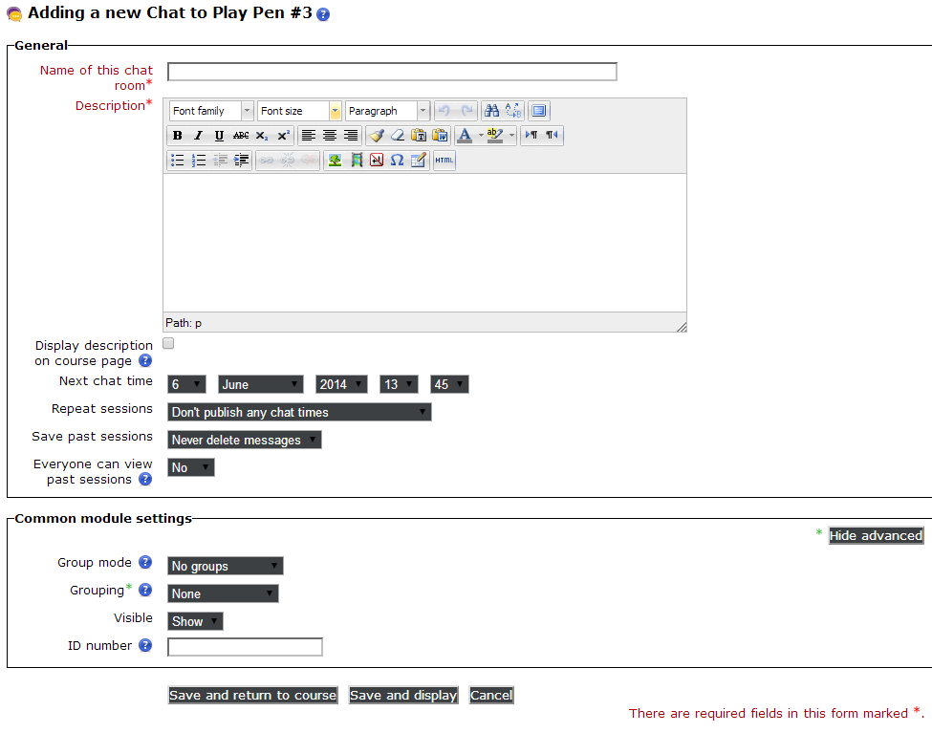

- If you want the Save past sessions, you can use the drop-down menu to set how long chat messages persist. The minimum is 2 days; the maximum is forever.

- Everyone can view past sessions: If set to no, then only instructors and moderators can view the chat logs.

7
9
8
- Group Mode and Grouping: Group mode and Grouping only works if you have already set up Groups/Groupings for the course. If you have Groups in your course, the following options are available.
No Groups means everyone is in the same community.
Separate Groups means students can only chat with their own group
Visible Groups means students can read other groups, but only post in their own

- Visible: Shows or hides the chat room on the course page. This is a means to disable a Chat.
Hidden: Instructors will see the Chat (light grey to show it is hidden), but students will not be able to see the activity.
Show: Visible to all.
- ID number is how the chat will appear in the grade book, should you choose to grade the chat activity.
- Click Save to finish setting up the chat.

Using a Chat

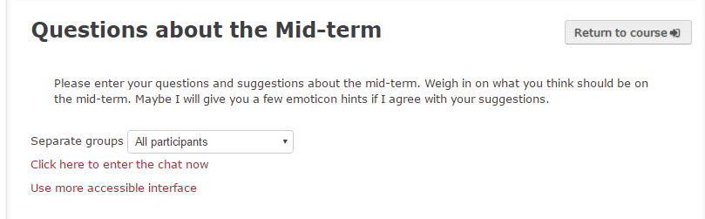
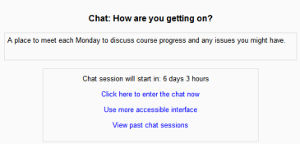
Entering the chat
When you enter the Chat, the Chat Name and Directions will appear on the top of the window. You may enter the Chat by clicking on the Click here to enter the chat now or Use more accessible interface. The appearance of the Chat differs for the accessible interface, having a more appealing, easier to follow application. (See screen shots below.)
What else you see when entering a Chat depends upon your settings. If you have groups in your course, you will have a drop down box to delineate who you are chatting with; the entire class or specific groups and whether they can view each other’s chats.
What you will see upon entry into the Chat depends upon what you chose for settings.
Example #1 Open Chat, Students are unable to see past Chats.
Example #2 Specified start for a Chat. Students are able to see past chats.
2
1

Click here to enter the Chat: The Chat window appears as a pop-up.

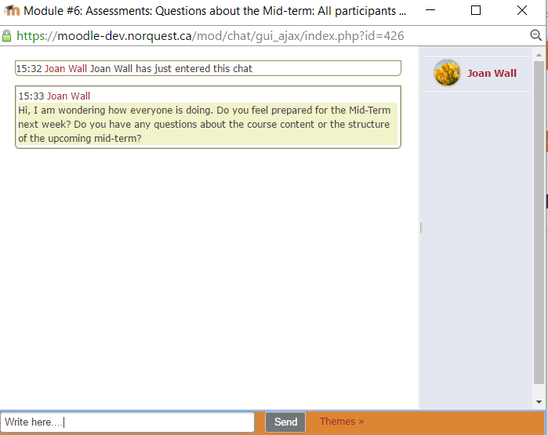

Use a simpler interface: The simpler interface provides a simpler looking chat room look with fewer frames. 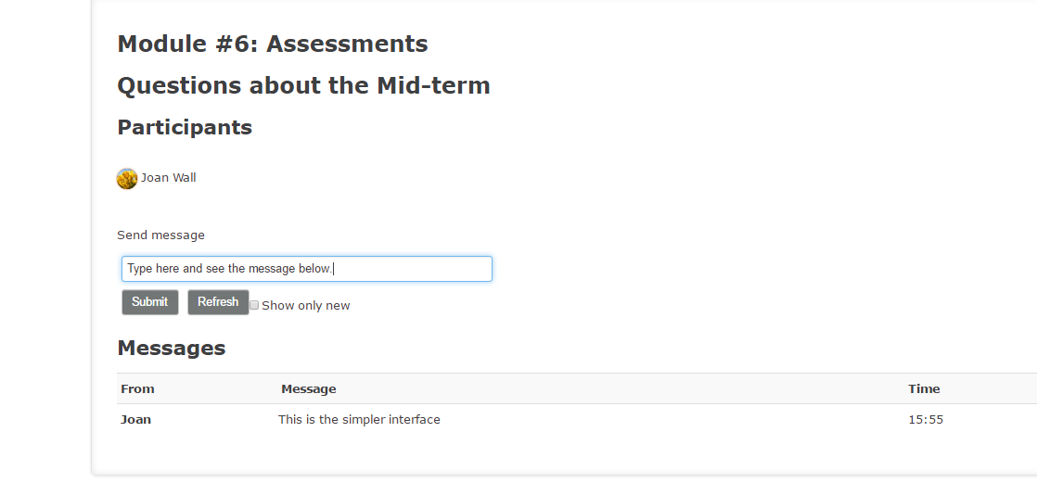

Two choices on Themes (or how the chats appear)
In normal view, the screen is in two parts with the participants on the right, the messages on the left and a box at the bottom into which users type their message and press "Send" to make their contribution. Under Theme there are two viewing options: Bubbles and Compact. (See below.)
Bubbles theme: Text appears in speech bubbles.

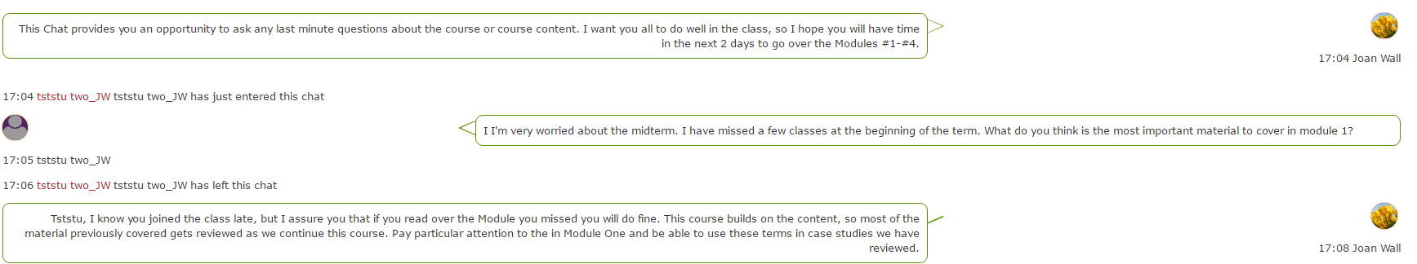

Compact theme: Information presented in a more linear fashion.
Beep and Talk
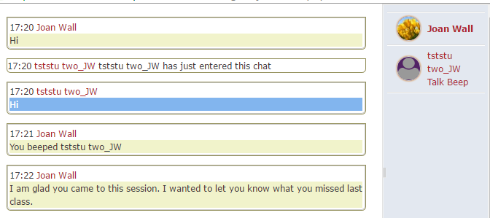
You can send a sound to other people by selecting the Beep link next to their name. A useful shortcut to beep all the people in the chat at once is to type "beep all".
If you click the 'Talk' link by a person's name, it will then add their name in the chat box to show your message is directed at that particular person.
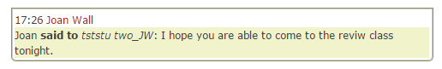

Chat Reports
When you click on the Chat, the Administration Block pertains to the Chat.
You may View past chat sessions. This will bring up a listing of each chat session under the current chat topic. The listings include the time the chat started and ended, which users participated, and how many messages each user sent. Individual sessions may be deleted by clicking the 'Delete' link.
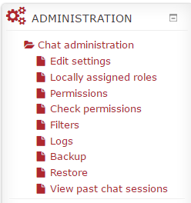

Logs
You may also view Logs. This will show you all the activity in the Chat. You may select one student to see their participation in the Chat. If you are interested in viewing one student, you may also select Create on the drop down menu for All actions to view when the student posted to the Chat versus when they viewed the Chat.
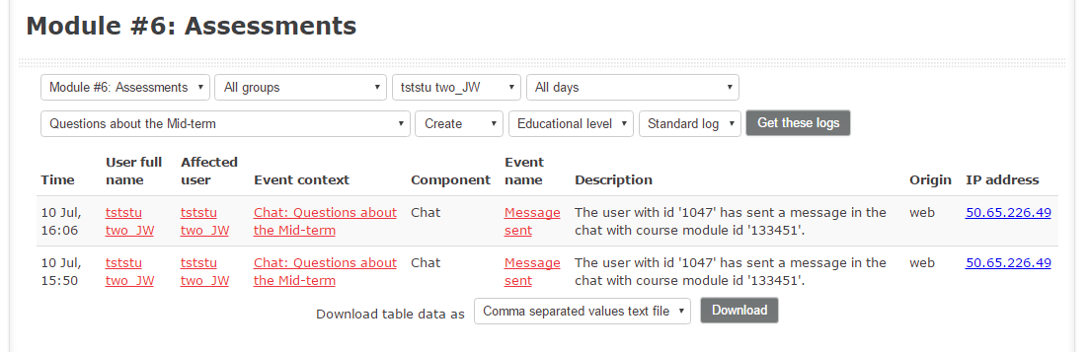Viewing Past Chats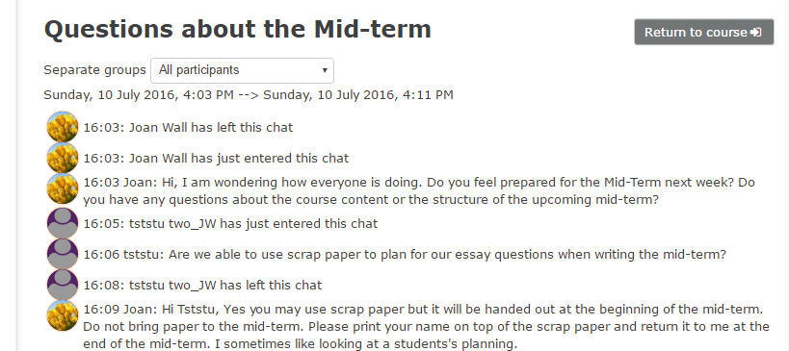

Delete a Chat
- Go to the course home page.
- Click on the Turn editing on button.
- Click Edit next to the Label resource.
- Click Delete.
Notes:
When you enter a Chat, you do not see the messages prior to your arrival. Stress to the students that, if they want to see all the chats, they should arrive in the Chat at the appropriate time, especially if you as the instructor are not allowing the students to view past Chat sessions.
For additional information, see Using Chats Moodle Docs or contact Moodle Help.

